# PICOCTF WRITEUPS GENERAL SKILLS

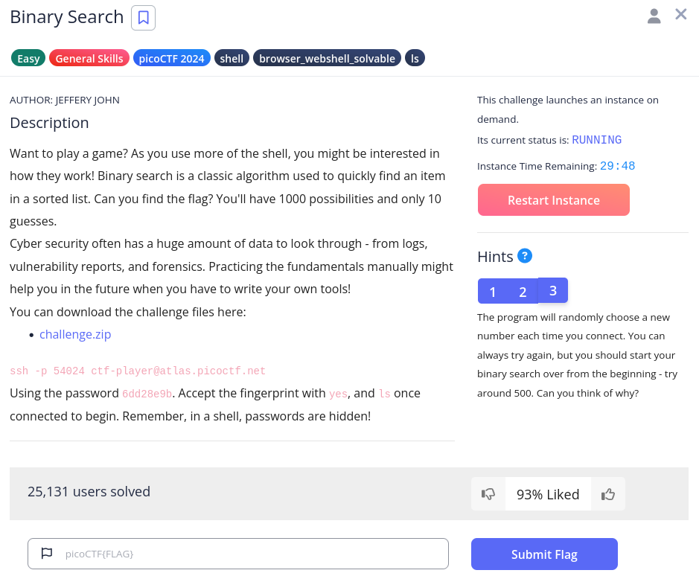

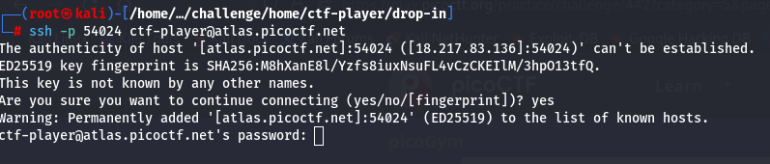

ohhhh after a lot of attempts finally get a flag!!!!!

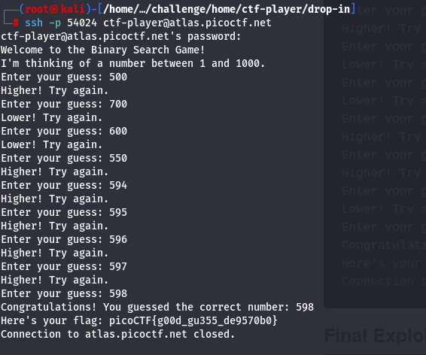

### Time Machine:

Download the challenge.zip and get to know that when I extract that there is “git” commands are used..

I oonly knows the git init, then i use chatgpt and get to know that same command is used to get the logs for the file but its git log

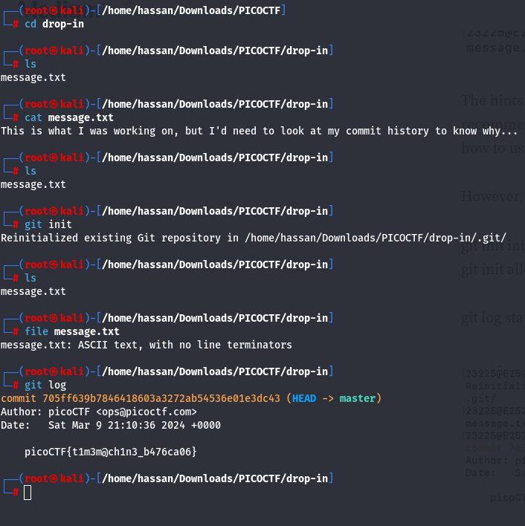

### Super SSH

<https://linux.die.net/man/1/ssh>

